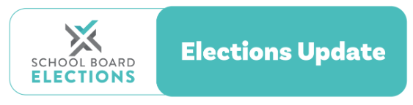

11 July 2022

2022 school board triennial elections
Returning officers' Memo 1

Kia ora,
Welcome, we are pleased to have you on board for the 2022 triennial elections! As a returning officer for the elections, you are responsible for running the election process at your school(s). We will be sending several memos between now and the end of the elections to support you in running a successful election process.
As a returning officer, you should confirm that:
- your school has a valid election date.
- you know the number of positions to be filled.
- you are familiar with the election process outlined in the Returning Officers’ Handbook; and that
- your school’s parent electoral roll is accurate.
Returning Officers’ Handbook 2022
The updated Returning Officers’ Handbook 2022 is now available on the School Board Elections website here. You should have also received a hard copy from your presiding member (board chair) or principal.
Are you a presiding member or principal receiving this email?
If you are a presiding member or principal receiving this email, this means your school currently does not have a returning officer registered. As soon as you have appointed your returning officer, please ask them to register on the School Board Elections website (School Board Elections) and pass this email update on to them.
Key Dates
The recommended election date is Wednesday 7 September 2022.
If your school chooses to use this date, the following table gives you all the key dates you need to meet.
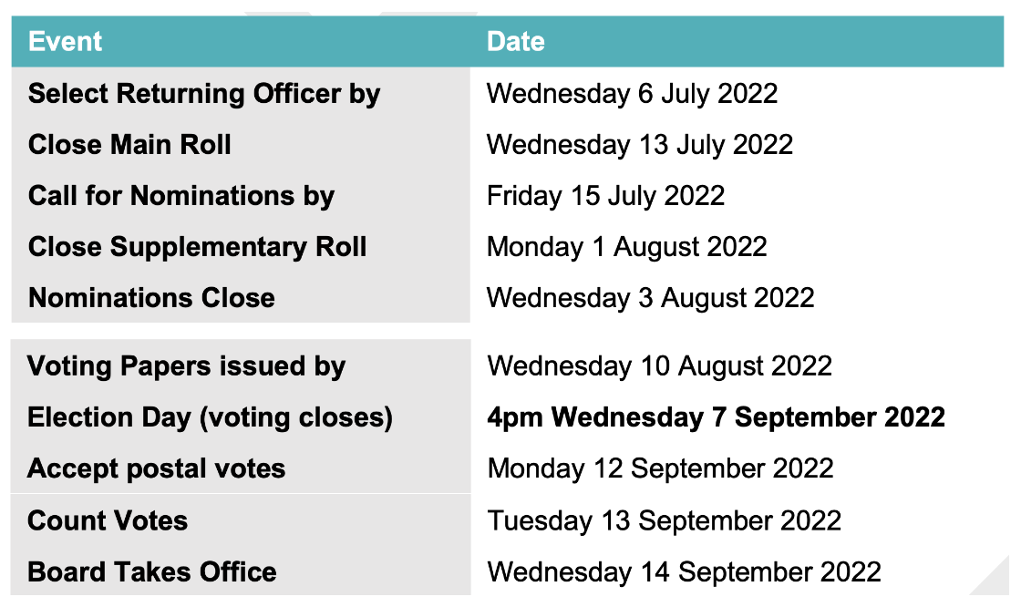
Note that if you are also the RO appointed to run the Student election, the Student Elections have been shortened to a 31 - day timetable. You can use the Student Election Planner Tool to work out the schedule (it can be found below the Parent and Staff Election Planner).The recommended date for the student elections this year is Wednesday 21 September 2022.
Working out the parent electoral roll
Ensuring the parent electoral roll is accurate is one of the first tasks of the returning officer. With so many blended families this can be difficult, especially in larger schools.
It is recommended that you display the roll at school and remind parents e.g. through the school newsletter to check that they are listed on the roll. If your school is using the recommended election date of 7 September, then the main roll closes on the 13th of July. Parents need enough time to check the roll and ensure that they are on it before the roll closes. Once the main roll closes a supplementary roll is opened to include any new parents or anyone left off in error.
For stand-alone intermediate schools, please also remember that parents of students enrolled in year 6 at nearby years 1-6 (contributing) primary schools, who are likely to be enrolled as a full-time student at your school in 2023, are eligible to participate in your 2022 parent election.
More information can be found on Page 10 of the Returning Officers’ Handbook 2022
Working out the staff electoral roll
All schools must run a staff election irrespective of when their current staff rep was elected.
- All permanently employed board staff, other than the principal, are eligible to participate in the staff election.
- Fixed-term staff are eligible to participate in the election if they have been continuously employed for a period of two months immediately before the roll closes.
- Staff who are parents have dual eligibility, but they cannot participate in both the staff and parent election. They are placed on the staff roll unless they advise the returning officer in writing that they wish to participate in the parent election. They will then be removed from the staff electoral roll and placed on the parent electoral roll. The returning officer must be advised before the electoral roll closes. Whichever roll the staff go on they will remain on that roll until the next triennial elections unless their status changes.
Note: If a staff member remains on the staff electoral roll they can stand, nominate, and vote. If they choose to be placed on the parent electoral roll they can only stand if they are not a permanent board employee.
Calling for Nominations
ROs need to call for nominations by putting a notice out to the community in the best possible way to capture the parent community and other interested parties. This could be in a newsletter, on the school website or on their Facebook page. Nomination forms and cover letters need to be sent out to everyone on the roll by email or post by July 15.
Nomination forms can be sent out to staff or these can be collected from a delegated place.
Have you got the right election day?
The recommended election date is Wednesday 7 September 2022. Boards can choose an alternative election date, but it must fall within the range of dates advised by the Ministry of Education: 5 September to 23 September 2022. Use the election planner tool to determine the required election timetable.
Update your election information
After you register, it is important that you log in and provide the following information about your school’s elections in the Returning Officer section of our website.
- your school’s election date
- the number of parent representative positions to be filled on the board
- the number of nominations (enter these as they are received – please enter 0 until then)
This information helps NZSTA to provide assistance to boards and returning officers.
Note: All schools must follow the election process for both parent and staff elections.
Returning officer payment
The Ministry of Education provides funding for school boards to hold their triennial and mid-term school board elections. Out of this comes the returning officer’s payment. The actual amount of the Returning officer’s fee is for your school’s board to decide. NZSTA recommends the fee is calculated on the basis of 50% of the school’s base election funding for 2022, plus 25% of the per-student amount.
Election funding 2022:
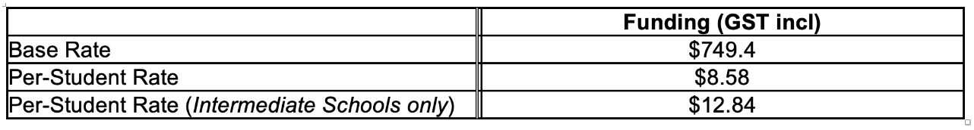
For more information on funding see the Ministry of Education website.
Contact the NZSTA Elections Team
Our team is here to support you and your board during the school board elections:
- School Board Elections website schoolboardelections.org.nz/returning-officers/
- NZSTA Election Advice Line 0800 ELECTION (0800 353 284)
- Email electionsadvice@nzsta.org.nz

Kind regards,
NZSTA Elections Team

