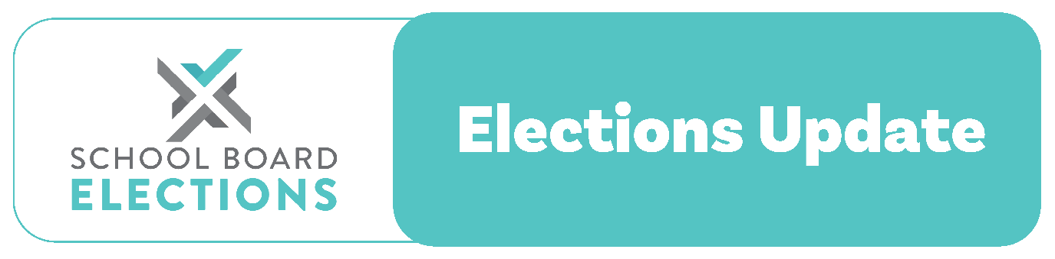

10 August 2023

2023 Midterm School Board Elections

Kia ora,
Our records show that your school is due to hold midterm elections in 2023.
We are currently waiting for a bill to be passed in Parliament allowing the midterm elections to be held earlier than the current legislation permits, which states that the midterm elections must be held at least 18 months after the triennials, which were delayed until September last year.
The date for the midterm elections will be in November 2023. We cannot confirm the exact date until the bill is passed but, in the meantime, we advise boards to start their planning. If your school is not holding a midterm election, please contact us now to update our records.
NZSTA (New Zealand School Trustees Association) is committed to supporting boards and schools to deliver successful elections.
Throughout the election period, we will provide regular updates and resources to ensure schools and kura have all the information they need to promote participation in the election and attract candidates from within their school community.
Recommended election date
Wednesday 15th November 2023 is the recommended election date for parent elections. If your school chooses to use this date, the following table gives you all the deadlines required to be met (you can now also create your own timetable using our election planner tool). If you decide not to use this date you must choose an alternate date in November.
The timeframe for all parent elections is 63 days.

Event | Date
Select Returning Officer by | Wednesday 13th September 2023
Close Main Roll | Wednesday 20th September 2023
Call for Nominations by | Friday 22nd September 2023
Close Supplementary Roll | Monday 9th October 2023
Nominations Close | Wednesday 11th October 2023
Voting Papers issued by | Wednesday 18th October 2023
Election Day (voting closes) | 4pm Wednesday 15th November 2023
Accept postal votes | Monday 20th November 2023
Count Votes | Tuesday 21st November 2023
Board Takes Office | Wednesday 22nd November 2023

Next steps for boards
Boards need to start planning for the elections now. We recommend that you tentatively confirm the election date at your next board meeting and discuss the appointment of a Returning Officer. If you plan to hold your election on November 15, we recommend that you appoint an RO in August to allow enough time to prepare the roll for display. NZSTA provides advice on these steps on our dedicated elections website.
Number of representative positions
Boards need to provide their returning officer with correct information about the number of parent representative positions to be filled in their midterm elections. If you are unsure how many positions need to be filled at the 2023 midterm elections, please contact our elections team. The number of positions will be less than half of the elected parents on the board. For example, if there are 5 elected parents on the board there will be 2 midterm positions available at these elections. If the board has 6 elected parents on the board, then there will be 3 midterm positions available.
If the board currently has a casual vacancy for one of its triennial positions this cannot be included as part of this election.
Opting out of the staggered election cycle
If the board wishes to opt out of the staggered election cycle they must still hold a midterm election in November and then in the triennial elections in 2025, all board members will step down and then all positions will be available for re-election.
Contact the NZSTA Elections Team
Our team is here to support you and your board during the trustee elections:
- School Board Elections website schoolboardelections.org.nz/returning-officers
- Email electionsadvice@nzsta.org.nz
Ngā mihi,
NZSTA Elections Team

