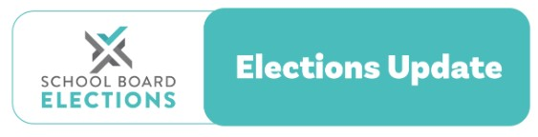
21 September 2023

2023 School Board Midterm Elections
Presiding Members and Principals Memo 5
Kia ora,
This memo provides advice on:
- the deadline and dates for nominations
- monitoring nominations
- what happens if a board does not receive enough nominations

Nomination period is underway
Most boards will be part way through their nomination period now. If you are using the recommended election date of 15 November 2023, you have until noon Wednesday 11th of October to receive enough valid nominations to fill the advertised number of parent positions If you are using the last official date to hold elections ( Wednesday November 29th ), then the last possible date to close nominations is Wednesday 25th October.

Monitor the number of nominations received.
Keep in touch with your returning officer to monitor the number of nominations received for parent elections. This will help you assess whether your board will receive enough nominations or if you need to engage in more activity to encourage parents/caregivers/guardians and community representatives to stand for the board.

Deadline for calling for nominations
The last date you can officially hold your election is November 29th. We are now approaching the final deadline to call for nominations which is Friday 6th October. If your returning officer has not yet called for nominations, you must advise them to do so now.
What happens if a board does not receive enough nominations?
If there are insufficient nominations the returning officer should promptly advise the presiding member for your board so that they can contact NZSTA for further advice. The positions will become casual vacancies and can be filled by holding a by election or if numbers permit the selection process can be used.

Contact the NZSTA Elections Team
Our team is here to support you and your board during the school board elections:
- School Board Elections website schoolboardelections.org.nz/returning officers/
- NZSTA Election Advice Line 0800 ELECTION (0800 353 284)

• Email electionsadvice@nzsta.org.nz Checklist & recap on our last elections memo
In Memo 4 we looked at:
- calling for nominations
- promoting the elections
- election resources (including resource translations)
- casual vacancies for triennial board members

Kind regards,
NZSTA Elections Team

